Project 7/8
Hannah Saunders (1093894)
RDW test centrum Lelystad
Sandra Hekkelman & Wouter Volders
08/06/2026
Eerste gelegenheid
Navigation research
Contents
1 Summary 2
2 Introduction 2
2.1 The problem 2
2.2 The Objective 3
2.3 The research question 3
3 Method 3
4 Results 4
4.1 Literature results 4
4.2 Experimental results 4
5 Conclusion 6
6 Glossary 7
7 References 8

Summary
This research paper will bring further insight into the question of “How to navigate a route using a self-driving kart without the use of a GPS and a GPU?”. This will be done by discovering what options already exist as well as which options could be feasible in regards to the question.
You will find that not research will result in a positive answer as some may only bring insight for the future.

Introduction
The project this research is for is the RDW (Rijksdienst voor het Wegverkeer) Self-Driving Challenge. It is a challenge setup by the RDW to gain more knowledge about autonomous driving cars and allow for them to judge if autonomous driving cars will be allowed to drive on Dutch roads sometime in the future. The reason for this challenge is because the car companies will only share a limited amount of information pertaining their autonomous driving software with the RDW due to the fact that they do not wish for their secrets to be leaked to other companies.
The challenge consists of two categories: the Open category and the closed category.
- In the Open category builds a kart from scratch and has the ability to choose what is on the kart and where, as long as they adhere to the guidelines set.
- In the Closed category, the category in which our team competes, is given a kart with a predetermined setup that cannot be changed. The only part the teams have a say in is the software side of the kart.
The entire aim of this challenge is to navigate a track that simulates realistic traffic scenarios, including pedestrian crossings, traffic lights, overtaking, sign recognition, and other common road situations.

  - The problem
One of the main issues is the fact that the team is not allowed to add or remove anything hardware related to the kart. As well as being limited to what the given hardware is capable of, such as the processing power of the Intel NUC minicomputer or the positioning of the camera’s. This restricts the team to what is possible with the kart.
Although there are a multitude of ways to navigate the most common and well known option is using a GPS (Global Positioning System). However as mentioned before the Intel NUC minicomputer has its limitations, one of which is the fact that it does not have a GPS. Another limitation the Intel NUC minicomputer has is its built in GPU (Graphics Processing Unit) isn’t the strongest, thus meaning that whatever program is chosen can’t be too GPU heavy as this could lead to programs running slower. Which could lead to the autonomous driving code to not being able to respond in time.

The Objective
The objective of this research is to research what options there are available for enabling the kart to navigate a predetermined route autonomously with the hardware limitations that it has and determine which option is best.

The research question
How to navigate a route using a self-driving kart without the use of a GPS and a GPU?
- What programs can be used for navigation?
- What programs could work within the parameters set by the limitations that the kart has?
- Which programs is the best option for the given parameters?

Method
To answer the research question, both literature and experimental research will be conducted. Literature research will bring insight to what options are out there and what they are capable of as well as which one will be used for this research, after which experimental research will be used to determine the which options is best suited for the objective.
First we need to determine what options are out there based of off the main limitations. These limitations being:
- Doesn’t require a GPS
- Isn’t GPU heavy or GPU reliant
There may be more limitations applicable in the future however to start researching these will do.
After determining which software programs to test the experimental research will begin. The literature research might not give enough insight to determine if the software program will work as wished. This is why experimental research will be needed. By installing and testing the different programs it will show what is or isn’t possible that documentation alone won’t show.

Results

Literature results
Researching the possibility of navigating by way of a map the following options were found:

ROS2 jazzy
ROS stands for Robot Operating System. It is an Open-Source and has a set of tools and software libraries for building robot applications. [1] After doing some searching for help guides as we had no knowledge of ROS a guide was found about using a ROS2 library for navigation called Nav2. [2] After reading through the instruction guide on how to install and use ROS Nav2 for Ros2 jazzy it was decided to attempt to use this program as it has several guides tied to each other to eventually be able to create a way of navigation. The Nav 2 library included two programs. One being Gazebo, a robot simulation environment and another being Rviz, a 3d visualizer. [3], [4]

COLMAP
Whilst doing research on navigating a pre-made map without a GPS for Nav2 to use, the possibility of using camera’s as a way of navigation was discovered. One of the options for this was COLMAP. COLMAP is a general-purpose pipeline for Structure-from-Motion (SfM) and Multi-View Stereo (MVS) with a graphical and command-line interface. One of its key features is the ability to create a 3d reconstruction based of off images. As well as the possibility to create an offline map and not active mapping. If this works it could mean that the map could be created using a computer with a GPU and then adding it onto the NUC to use without having to worry about the GPU. It was decided to give this a try to see if the results would benefit the project. [5]

SLAM
Whilst looking through more of what Nav2 had to offer, Navigating while Mapping also known as SLAM (Simultaneous localization and Mapping), was discoverd. [6] SLAM gave insight into other programs which use SLAM. After researching this further the following programs were found and tested:

PySLAM
When reading the Github several options to use SLAM where discovered. The program runs on Python which a plus as the line detection also runs on python which reduces the chance of compatibility issues. After reading through the different options it was decided to give this a try. [7]

RTAB-Map
RTBA-Map also known as Real-Time Appearance-Based Mapping. RTBA-MAP was recommended by an expert at the robotics department of the Technical University delft, TU Delft for short. He advised trying this program to see if this is what we needed. After looking into the program it was decided to give it a go. As it used a camera to create a map which then allowed it to use said map to locate itself. [8]

Experimental results
The following part will explain what the results of trying out the different options that were covered in section 4.1.

ROS2 Jazzy
As it was being attempted to apply the guides to what our project needs, it was first discovered how difficult using Gazebo was without in depth knowledge of ROS itself. After further experimentation is was realised that altering the guides instructions to what the project needed was difficult with the limited amount of knowledge and time that was available. As the project simply didn’t understand ROS2 enough to be able to apply the changes needed for a successful recreation of the course for navigational purposes.

COLMAP
Experimenting with COLMAP made it clear the running this on a computer with a GPU was mandatory as the first reconstruction took over 1 day, 11 hours, 19 minutes and 16 seconds.
To be able to reconstruct a 3d model in was necessary to cut the video into separate images.
The first attempt used all 3 camera’s, images cut from the video at 30 frames per second to as well as exhaustive matching reconstruct only a part of the track.
The lefthand image shows the results of the first attempt of reconstruction.
A second attempt with the same settings but instead being the full track. Ended up being stopped due to the large amount of diskspace used for the database as it reached a size of 250 GB and wasn’t even completed.
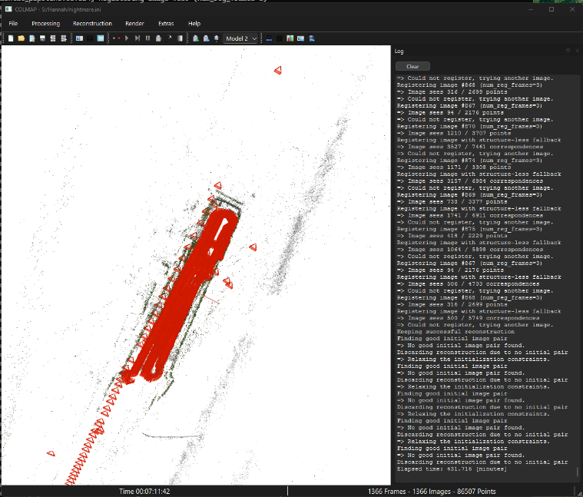
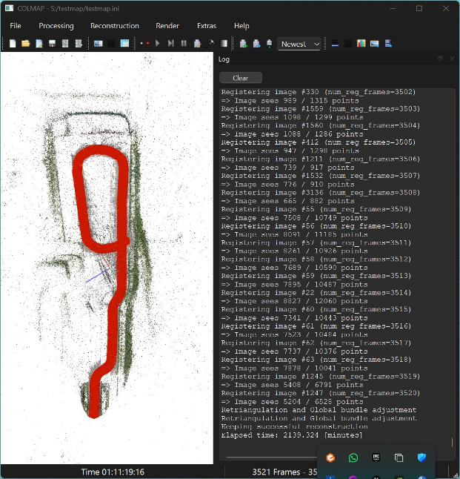
A third attempt using a single camera, 5 frames per second and sequential matching went much faster and resulted in the righthand image.
Left image: first attempt & right image: third attempt
It was however discovered that the data COLMAP returns unusable is as when it was attempted to use the map generated by COLMAP in Gazebo and Rviz it was discovered that the 3d image created was being displayed incorrectly.

PySLAM
After PySlam was installed it was decided to try out its Visual odometry feature. It seemed to show what this project needed with the demo setup however when attempts were made to apply it to our video, it was discovered that we were unable to acquire data values that were needed for the groundtruth dataset which was needed to run the program correctly. Although several attempts were made to acquire said data values none where successful.

RTBA-Map
Using RTBA-Map did require the installation of ROS2 however this was only needed as its backend as the program itself had its own graphical interface. Using RTBA-Map was relatively simple as it had all the installation instructions and tutorials on how to use it that were needed. [9] After adjusting the values to suit our video an attempt was made to run the program.
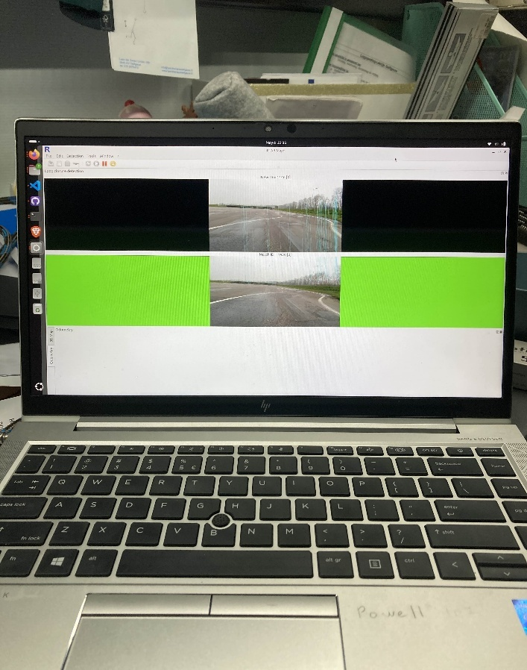

As seen in the image above the program ran successfully. Later on however when attempting to turn the processed video into a map the entire program crashed. After several attempts were made to fix this it was discovered that using monocular mapping in this program wasn’t feasible as it needs to be able to determine distance made. This is possible using a stereo camera setup which in other words means that is program is also not an option.

Conclusion
In conclusion based upon the results and current setup of the kart the answer to question: “How to navigate a route using a self-driving kart without the use of a GPS and a GPU?” is inconclusive as the tested programs weren’t able to give a functioning result.
Based on the results from the different programs there are a few mayor issues that resulted in the inconclusiveness of this research paper. Such as understanding of a program, missing datasets or incompatible setup. Outside of these issues the results of the research does show that it could be possible to navigate a route if the RDW makes changes to the setup. An example of these changes would be a stereo camera setup or a GPS.

Glossary
RDW – Rijksdienst voor het Wegverkeer. This is the Dutch Vehicle Authority responsible for vehicle registration, determine road worthiness of vehicles and road safety.
Intel NUC – A small form-factor computer developed by Intel, used in this project to process sensor data and control the autonomous kart.
Gazebo – an open-source 3D robotics simulator. Can be used to design, test and visualize robots in a virtual environment.
Rviz – is a Visualization tool for ROS which allows users to visualize robot states, sensor data, and environments in real time.
Structure-from-Motion – is the process of reconstructing 3D structure from its projections into a series of images. The result is a 3-D reconstruction of the object, and the reconstructed intrinsic and extrinsic camera parameters of all images.
Multi-View Stereo – is a computer vision technique used to reconstruct dense 3D models of a scene from multiple 2D images taken from different viewpoints.
Visual odometry – is the process of determining the position and orientation of a robot or camera by analysing a sequence of images.
Groundtruth - information known to be true or real, obtained through direct observation or measurement, often used as a reference standard in data validation and modelling.
Monocular mapping – utilizes a single camera to create a 3D representation of a space.
Stereo camera – is a camera system with two or more lenses that captures images from slightly different angles, that still overlap, to create three-dimensional (3D) images and depth perception.

References
[1] ‘ROS 2 Documentation — ROS 2 Documentation: Jazzy documentation’. Geraadpleegd: 8 juni 2026. [Online]. Beschikbaar op: https://docs.ros.org/en/jazzy/index.html
[2] automaticaddison, ‘How to Install ROS 2 Navigation (Nav2) – ROS 2 Jazzy’. Geraadpleegd: 8 juni 2026. [Online]. Beschikbaar op: https://automaticaddison.com/how-to-install-ros-2-navigation-nav2-ros-2-jazzy/
[3] ‘Setting up a robot simulation (Gazebo) — ROS 2 Documentation: Jazzy documentation’. Geraadpleegd: 8 juni 2026. [Online]. Beschikbaar op: https://docs.ros.org/en/jazzy/Tutorials/Advanced/Simulators/Gazebo/Gazebo.html#prerequisites
[4] ‘RViz — ROS 2 Documentation: Jazzy documentation’. Geraadpleegd: 8 juni 2026. [Online]. Beschikbaar op: https://docs.ros.org/en/jazzy/Tutorials/Intermediate/RViz/RViz-Main.html
[5] ‘COLMAP — COLMAP 4.1.0.dev0 | 43dd3bb2 (2026-03-16) documentation’. Geraadpleegd: 8 juni 2026. [Online]. Beschikbaar op: https://colmap.github.io/
[6] ‘Navigating while Mapping (SLAM) — Nav2 1.0.0 documentation’. Geraadpleegd: 8 juni 2026. [Online]. Beschikbaar op: https://docs.nav2.org/tutorials/docs/navigation2_with_slam.html
[7] L. Freda, luigifreda/pyslam. (8 juni 2026). Python. Geraadpleegd: 8 juni 2026. [Online]. Beschikbaar op: https://github.com/luigifreda/pyslam
[8] ‘RTAB-Map’, RTAB-Map. Geraadpleegd: 8 juni 2026. [Online]. Beschikbaar op: http://introlab.github.io/rtabmap/
[9] ‘Home’, GitHub. Geraadpleegd: 8 juni 2026. [Online]. Beschikbaar op: https://github.com/introlab/rtabmap/wiki/Home

